

A Data Analysis ReportOn

**“SHOPNEST STORES SALES ”**

As a fulfilment of

**CAPSTONE PROJECT**

**(POWER BI)**

**Submitted By:**

**GOURAB MUKHERJEE**

#### Batch No.: DAP-202402-1

**Submitted to:**

**TEAM SKILLOVILLA**

**QUESTION STATEMENT**

**ShopNest Store Capstone**

100 marks

**Resources**

ShopNest stands as the leading department store in the e-commerce marketplaces in Portugal. Serving as a seamless link, it connects small businesses from various regions in Portugal to channels, streamlining the process with a single point of contact. Through the ShopNest Store, these merchants can showcase and sell their products, with the added convenience of direct shipment to customers facilitated by ShopNest logistics partners. The provided data represents authentic commercial information that has undergone the process of anonymization.

This capstone has 9 datasets and the descriptions are below :  
  
**Customers_dataset :**

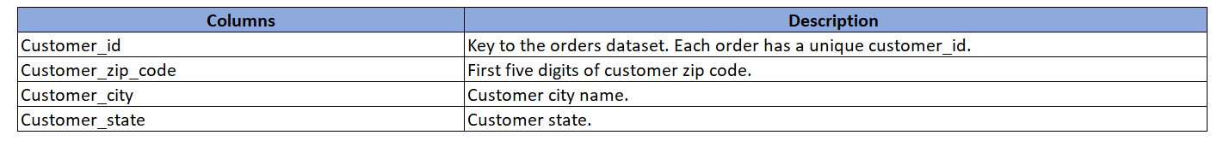

**Geolocation_dataset :**  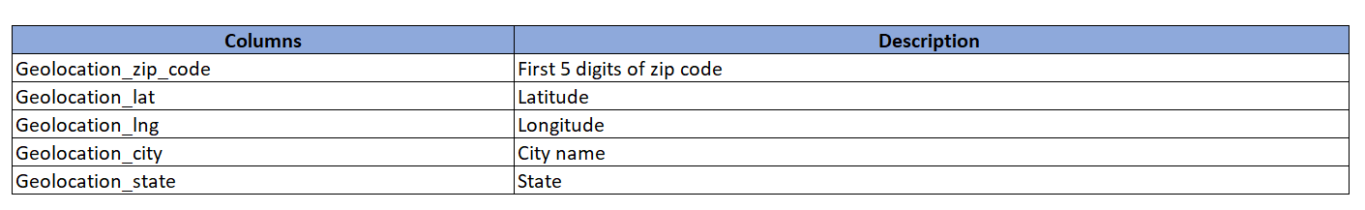

**Order_items_dataset :  
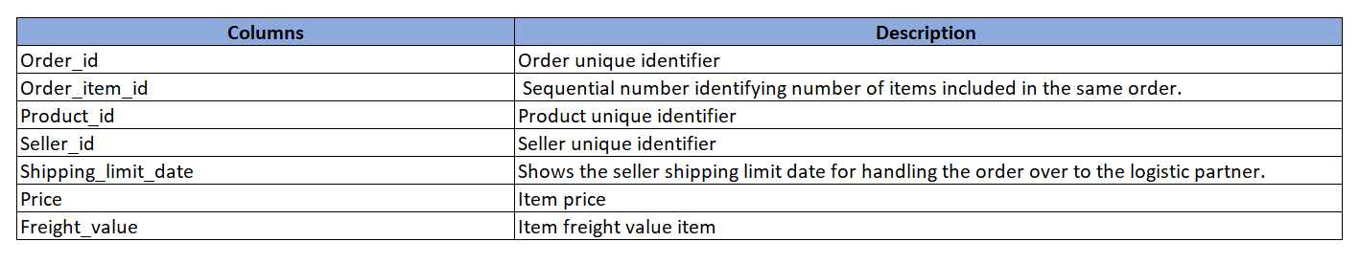**

**Order_payments_dataset :  
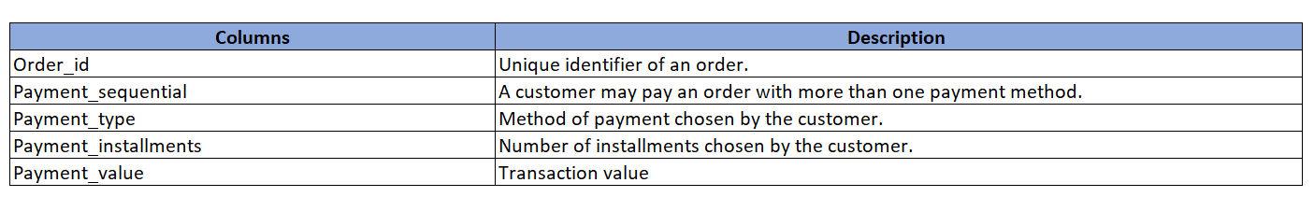**

**Order_reviews_dataset :  
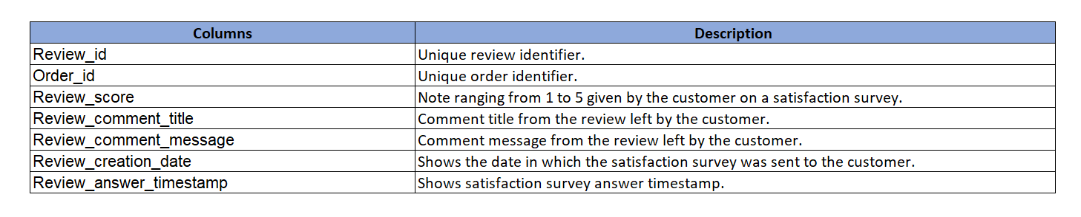**

**Orders_dataset :  
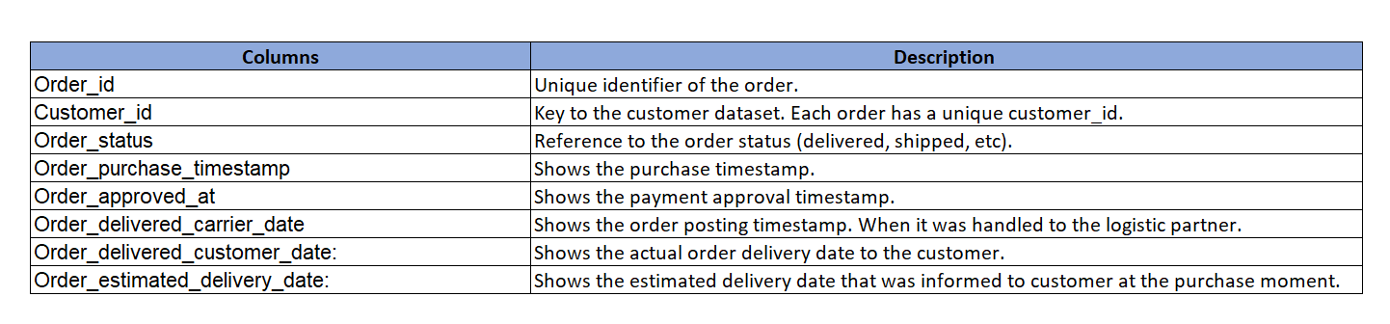**

**Products_dataset :**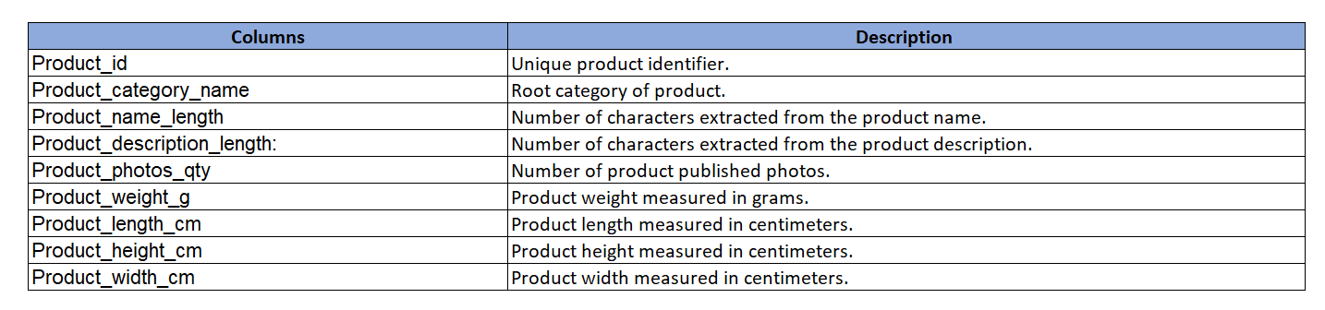

**Sellers_dataset :**

**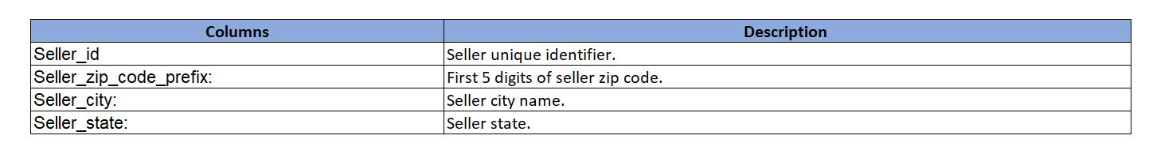  
Product Categories :**

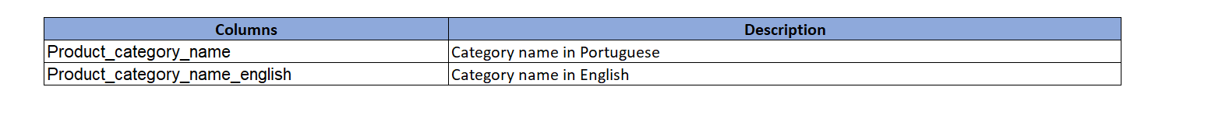

**Tasks to do :**Design a comprehensive Power BI dashboard to address key business analytics for a retail dataset. The following analytical questions should be answered through your dashboard:

1. Identify the rating distribution in the Shop_Nest dataset, showcasing ratings categorized as Excellent, Very Good, Good, Bad, and Very Bad, along with corresponding orders.
2. What are the top 10 and bottom 18 most popular product categories in the ShopNest dataset? Please list them based on the number of orders.
3. List the total number of active sellers by yearly and monthly.
4. Which payment methods are most commonly used by ShopNest customers.
5. Identify the product category. wise profit margin using the formula  
   **Hint:** **(Payment value -price + Freight_value)/payment_value*100** (Rounded to two decimal points).
6. Determine the monthly payments made by customers using credit cards.
7. Identify sellers categorized by city, excluding cities starting with the letters S and B.
8. Create a dynamic visual that compares the number of delayed orders to the number of orders received earlier for each month. Utilize the drill through the cross-report feature to provide a detailed analysis of late and on-time deliveries.

**Instruction to submit the capstone:**

1. **PowerBI Dashboard (PBIX File):**
   * Provide the Power BI dashboard in a PBIX file format. Create a Power BI dashboard in a single sheet that includes all the charts for the given 8 questions. The file should contain all necessary visualizations, slicers, and data connections for the analysis.
2. **Dashboard Report (DOC File):**
   * Create a detailed report document in DOC format that explains the dashboard comprehensively.
   * Include screenshots or images of the dashboard visuals in the document for a clear representation.
   * For each question/task outlined in the Power BI Capstone Project, include a section with the following details:
     + **Question Statement:** State the question/task.
     + **Visualization:** Include an image of the corresponding visualization(s) in the dashboard.
     + **Explanation:** Provide a clear and concise explanation of the visual, highlighting key insights and findings.
   * Ensure the document is organized, with each section corresponding to a specific question or aspect of the dashboard.
   * Submit your capstone in the zip file containing the dashboard and report.

# ABSTRACT

**Introduction:**

ShopNest stands as the leading department store in the e-commerce marketplaces in Portugal, serving as a seamless link connecting small businesses from various regions to online channels. In today's dynamic business environment, the importance of data analytics cannot be overstated, particularly in enhancing decision-making and operational efficiency.

**Purpose of the Analysis:**

The purpose of this project is to delve into ShopNest's operations through data analytics, aiming to uncover insights that drive business growth and optimization. By leveraging the power of data, this project seeks to provide ShopNest with actionable insights to improve decision-making and operational effectiveness.

**Scope of the Analysis:**

This project encompasses a comprehensive range of analyses, including but not limited to top categories by total price, delayed orders analysis, monthly comparison of delayed and on-time orders, payment method analysis, product rating analysis, state-wise sales analysis, seasonal sales patterns, and revenue analysis. Each analysis sheds light on different aspects of ShopNest's operations, contributing to a holistic understanding of its performance in the e-commerce marketplace.

**Methodology Overview:**

Power BI is utilized as the primary tool for data analysis and visualization in this project. The dataset used for analysis has been anonymized to ensure confidentiality and privacy. The analytical approach involves a combination of exploratory data analysis, data visualization techniques, and statistical methods to extract meaningful insights from the data.

**Expected Outcomes:**

The expected outcome of this project is to provide ShopNest with valuable insights and strategic recommendations to optimize its operations, enhance customer experience, and drive business growth. By harnessing the insights derived from data analytics, ShopNest can make

Contents

**ABSTRACT 5**

**RATING DISTRIBUTION……………………………………………………………………………………………………………………………….7**

**TOP AND BOTTOM PRODUCT CATEGORIES………………………………………………………………………………………………..8**

**MONTHLY AND YEARLY ACTIVE SELLER…………………………………………………………………………………………………..…9**

**PAYMENT METHOD ANALYSIS………………………………………………………………………………………………………………...10**

**PROFIT MARGIN DISTRIBUTION……………………………………………………………………………………………………………….11**

**CREDIT CARD PAYMENT ANALYSIS………………………………………………………………………………………………………..…12**

**SELLERS TERRITORY……………………………………………………………………………………………………………………………..….13**

**DELAY VS ON TIME DELIVERY………………………………………………………………………………………………………………....14**

**CONCLUSION……………………………………………………………………………………………………………………………………15**

# RATING DISTRIBUTION ANALYSIS

**Visualization :**

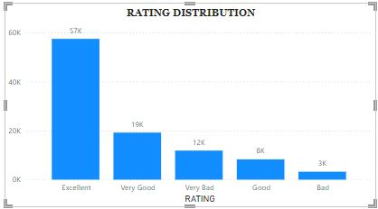

**EXPLANATION:-** The Column chart showcases the Rating Distribution with their Respective orders. We Can Clearly Visualize That 57k Orders are Rated Excellent, 19k Rated Very Good, 12K rated Very Bad Good rated 8k And Bad rated 3k. Through This observation of database We can clearly Express Excellent Rating Is majorly executed, That’s The positive Sign, But Apart From That We should Look forward to 12k Very bad rated orders we have to work over there. Good rating fell short But good news is bad rating also fell short. We need to focus On Very bad Rating customers Why they Give in huge margin in terms of particular respective ratio.

Rating of Excellent is in Quite High That’s the relief Statement But We need to Focus Over very bad Rating , The ratio Should be Reduced In Future Team need To take Care of It.

# TOP AND BOTTOM PRODUCT CATEGORIES

**Visualization :**

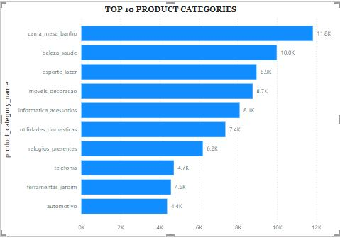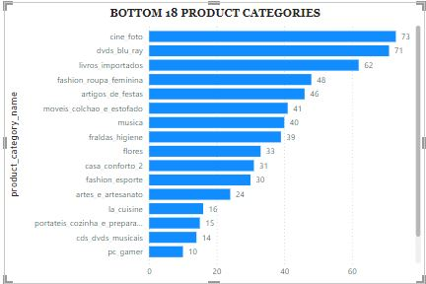

**EXPLANATION:-** The bar chart showcases the top 10 product categories and Bottom 18 Products In terms of Numbers of Orders , revealing compelling insights into number of Orders Distribution also. The Visualization Clearly State That **Cama_mesa_banho** This Particular Product Category Dealing With Maximum Number Of Orders. Its Dealing With **11.8K** orders And Followed By **Beleza Sauda (10k), Esporte lazzer(8.9k),movie_decoracao(8.7k),Informatica_acessorios(8.1k)** and So on.

Where We can see that On the Other Side We can Visualize Through Bar Chart The Bottom 18 Product Category On the Basis Of Number Of orders They Acquired .On That Basis We can Found Thorough Our Analysis The lowest Orders Dealing product Name **Fraldas_higiene** it Deals With Only **39 Orders,** Followed By **Musica(40), Moveis_colchao_e_estofado,(41)** And So on.

# MONTHLY AND YEARLY ACTIVE SELLERS

**Visualization :**

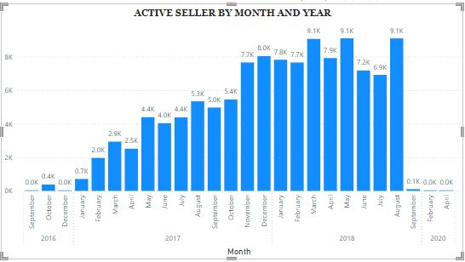

**EXPLANATION:-** The Column Chart Showcase The Numbers Of Active Sellers On The Level Of Year And Month Wise.We Can Clearly Visualize That The Column Chart Increasingly Getting High Yearly **From 2016 to 2018** But It Fell short dramatically in The Year 2020.Through This Analysis We can See in the **month of March , August,May of the year 2018** Its Number of Active sellers Is Highest its **9.1k** Active Sellers Are over there.

# PAYMENT METHOD ANALYSIS

**Visualization :**

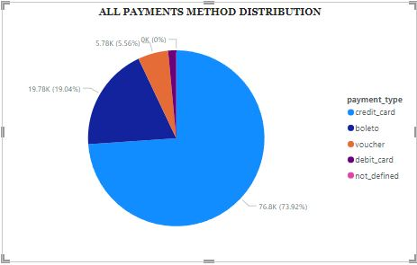

**EXPLANATION:-**  The Question We have been Asked That Which payment Method Are Most Commonly Used By Shopnest Customers. Through This Pie Chart We Can Clearly Visualize That Through **Credit card** Shopnest Customers Transacted Frequently , In the Pie Chart We can clearly see that Credit card Holding The Lion Share **74%** people Using **Credit card payment system** and **19%** people are Using **Boleto** Followed by **Voucher** and **Debit card** Payment Method.

# PROFIT MARGIN DISTRIBUTION

**Visualization :**

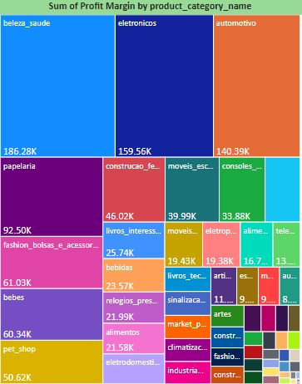

**EXPLANATION:-**  Here our Task Was To find the Product Category With Respective Profit Margin. Through This Visualization Tool we can Clearly see that There are Lots of product Category Laying In clattered Way But Among From Them We can see That **beleze_saude** Holding Lion Share Of Profit Margin **186.28k** along with **eletronicos (159.56k). Automotivo** is also holding The share of **140.39k** profit margin Share. We can Found In this Graph Below section That Plots are Getting So Much Clattered As their Profit Margin Is very low.

# CREDIT CARD PAYMENT ANALYSIS

**Visualization :**

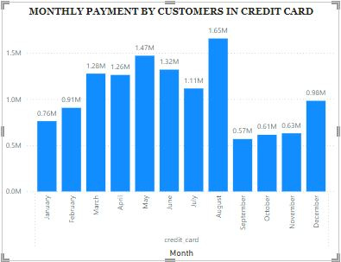

**EXPLANATION:-**  We need to analyze the monthly payments made by customers using credit cards Through This Column Chart we can clearly observed that In month Of august The Customers Transacted Maximum Time Through Credit card payment and In the month Of September We can Found Transacting Numbers Fell short. Through This Column Chart We can visualize clearly About Monthly Payment Frequency of credit card In Shopnest database.

**SELLERS TERRITORY EXCLUDING S &B**

**Visualization :**

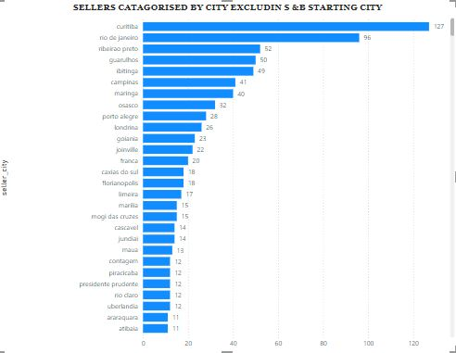

**EXPLANATION:-** Here is Our Task is to Identify Sellers Territory Excluding Those City Which Are Starting letter Is **S & B.** Through This Bar Graph We can Visualize That the numbers Of Sellers in Maximum Number In the **Curitiba (127)**  This Bar Chart Clearly state the territory Wise active Sellers in shop nest data base.

# MONTHLY COMPARISON OF DELAYED AND ON-TIME ORDERS

**Visualization :**

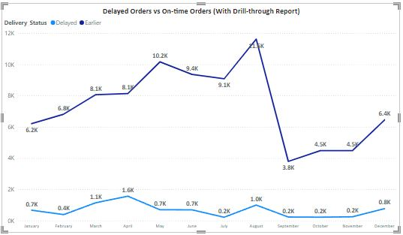

**EXPLANATION:-** The line chart provides a detailed comparison of delayed and earlier orders across all months, offering valuable insights into order fulfillment performance throughout the year.

Notably, August emerges as the month with the largest disparity between delayed and earlier orders, boasting 11,620 earlier orders compared to a mere 996 delayed orders, showcasing exceptional efficiency in meeting customer demands. Conversely, July records the smallest gap between delayed and earlier orders, with 9,078 earlier orders slightly surpassing 216 delayed orders. The trend continues across the remaining months, with September showing 3,790 earlier orders against 231 delayed, October exhibiting 4,480 earlier orders versus 222 delayed, and November with 4,483 earlier orders compared to 245 delayed. These consistent findings underscore the organization's strong performance in fulfilling orders promptly.

December and January witness increased delays, with 767 and 667 delayed orders respectively, potentially due to heightened customer demand during the holiday season. Conversely, June and May show relatively fewer delayed orders, with 691 and 696 delayed orders respectively, reflecting efficient order processing and logistics management during these periods. By leveraging these findings, the organization can proactively address operational bottlenecks, optimize resource allocation, and implement targeted strategies to mitigate delays, thereby enhancing customer satisfaction and loyalty.

# CONCLUSION

**Fulfillment Efficiency:**

The analysis of delayed orders reveals insights into fulfillment efficiency, highlighting potential challenges in logistics and supply chain management.Addressing systemic issues and streamlining processes can enhance order fulfillment and customer satisfaction.

**Payment Method Preferences:**

Credit card emerges as the dominant payment method, indicating a preference for convenience and flexibility among customers.Offering diverse payment options caters to varying customer preferences and enhances transaction efficiency.

**Strategic Implications:**

The insights gathered from these analyses provide valuable guidance for strategic decision-making, resource allocation, and operational enhancements.By leveraging actionable intelligence, organizations can refine processes, optimize sales strategies, and drive sustained business growth and profitability in the competitive e-commerce landscape.

In conclusion, a comprehensive understanding of sales performance, fulfillment efficiency, customer preferences, and revenue trends empowers businesses to make informed decisions and implement targeted strategies for sustained success and competitive advantage in the dynamic e-commerce market.

* **THANK YOU TEAM**